**Alice P. Fabrykiewicz, RDH, BS – CDHA Scholarship Application**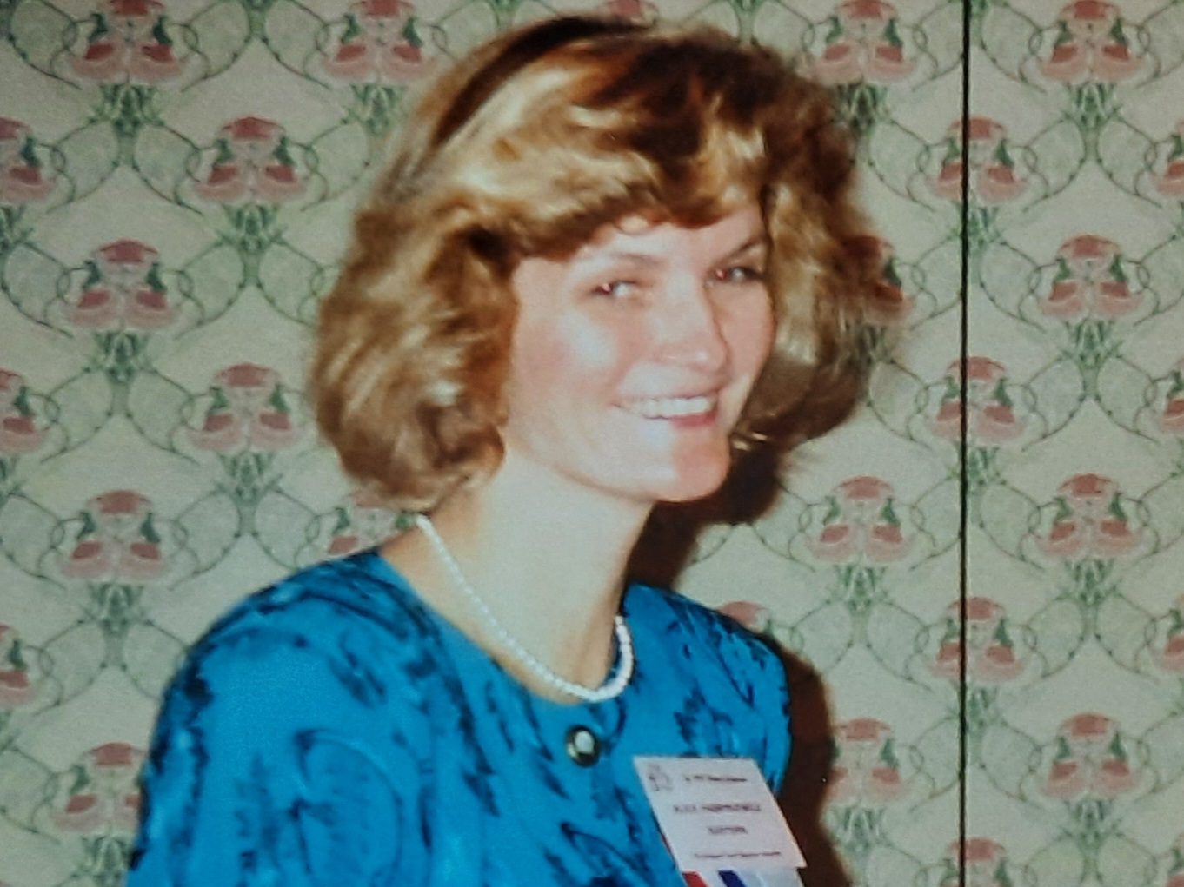

In April 2025, CDHA will be awarding a scholarship in the amount of $500.00. Please submit the following completely and carefully. All applications and attachments must be postmarked by March 15, 2025.

NOTE: Incomplete applications will not be considered. You must be a Connecticut resident to apply.

NAME ____________________________________ PHONE _(____)_______________

ADDRESS______________________________________________________________

CITY ___________________________________STATE ___________ ZIP__________

EMAIL _________________________________________________________________

MARITAL STATUS (optional)_________ # OF DEPENDENT CHILDREN ________

HIGH SCHOOL___________________________________ GRAD. DATE__________

HYGIENE SCHOOL FOR FALL 2024 SEMESTER: ___________________________________________________________________

CLASS STATUS @ FALL 2024: FRESH.___ SOPH.___JUNIOR___ SENIOR___

STUDENT STATUS @ FALL 2024: FULL TIME ____ PART TIME ____

SADHA MEMBER?______

Please submit a resume including any work experience, involvement in any school, community, or volunteer activities, and any awards and/or honors received; please include dates for all activities.

Please submit an essay telling us a little about yourself and how you came to pursue dental hygiene, along with some objectives for your personal and professional growth after your licensure.

Please include three letters of reference (two professional/educational and one personal).

Financial necessity will be taken into consideration.

Send completed application /attachments ,and have your school forward your most recent transcript to:

CDHA Scholarship

c/o Jenifer Mancini, RDH

99 Atwood Road

Thomaston, CT 06787

Or email jenmancinirdh@gmail.com